IP SCAN Using Ipinfo.io and Mx Tool and Commands

- Objective:
To use IP Scan for mapping and analysing network devices, enabling better visibility, detection of anomalies, and strengthening overall network security.

- Overview:
IP Scan is a network scanning tool used to discover and analyse devices connected to a network. It helps security teams identify active hosts, open ports, and running services. This information provides insights into potential vulnerabilities and unauthorized devices in the network.

- Step-By-Step:
Step 1: Search for ipinfo.io in Browser and Enter the IP Address
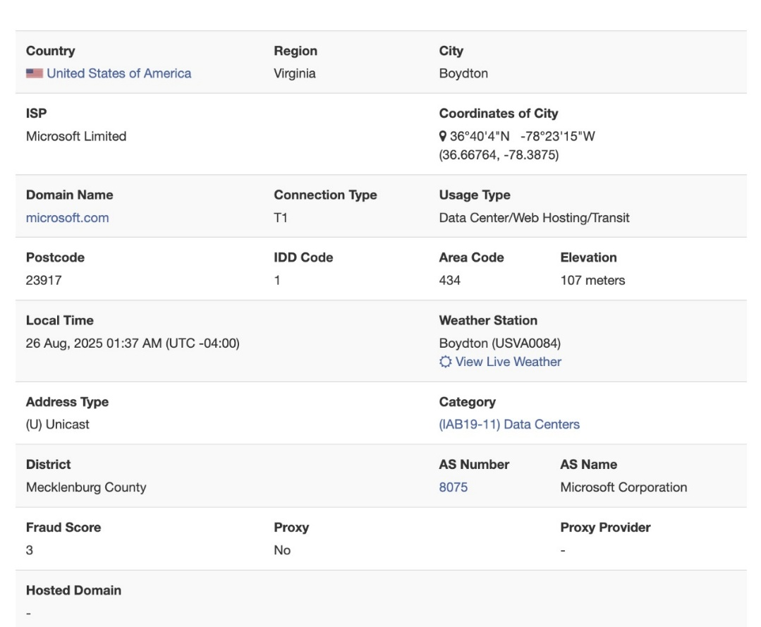
Step 2: Search For MXTOOL in Browser and enter the domain name or IP Address
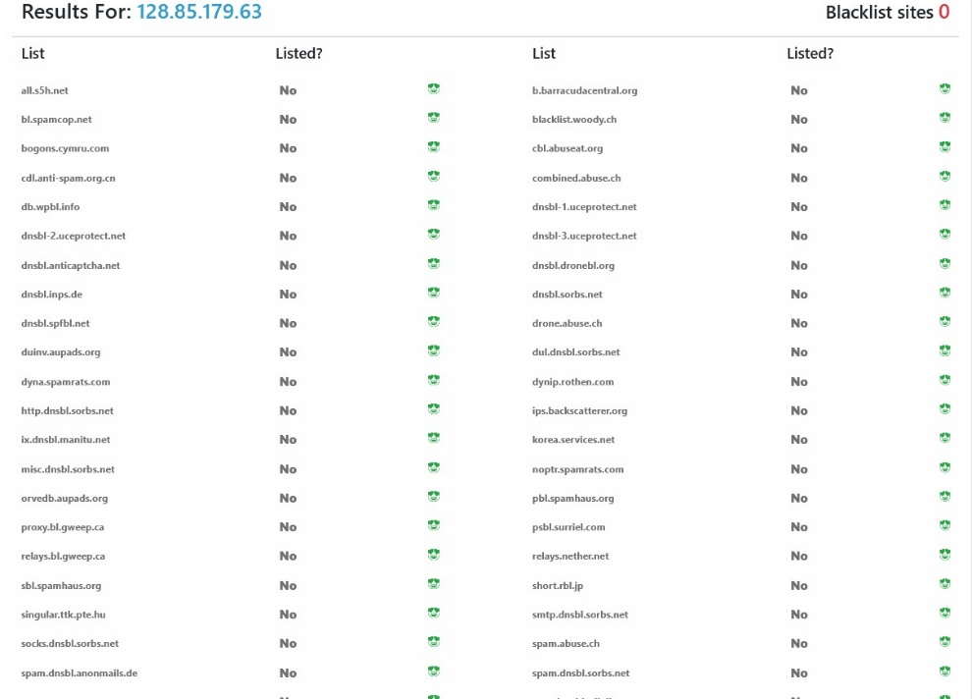
Step 3: Run the Nmap Commands for verifying the vulnerabilities of the IP address
- sudo nmap install
- nmap -Pn 128.85.179.63

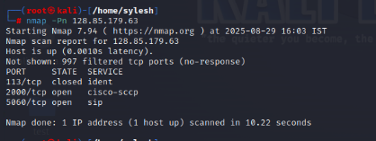

- whois 128.85.179.63 for knowing the IP Details
